[ Insert official UPAEP logo ]
UPAEP · Decanato de Ingenierías
EVIDENCE — US17-T4
Test event recording
SmartGreenAI: Cilantro Crop

1. Task information
Task ID | US17-T4
User Story | US-17 — Record actuator activation events
Sprint | Sprint 3 (2026-10-12 – 2026-10-30)
Week | Week 3
Responsible | Carlos Ramirez Mendoza
Peer reviewer | Jorge Velez Delgado
Planned / actual hours | 0.5 h / 0.5 h
Completed on | October 29, 2026
Status | Done

2. Task description
Verify that manual and automatic activations produce events with the correct source, user and duration.

3. Completion conditions
✓ Condition 1: Manual activation recorded correctly.
How it was verified: The manual activation was recorded with source MANUAL, the producer's user and 5 minutes.
Events in the database (latest manual and automatic activations) (2 rows; US17-T4_Test_Event_Recording_1.csv)
id | created_at | action | source | user_email | duration_min | reason
evt-68c58affd539 | 2026-09-29T04:40:13.819Z | ON | MANUAL | producer@smartgreen.ai | 5 | Manual control from the dashboard.
evt-486e05607965 | 2026-09-29T04:54:31.258Z | ON | AUTOMATIC |  | 3.5 | Soil moisture is 58.1 %, below the minimum of 60 % for 2 …
SQL: SELECT e.id, e.created_at, e.action, e.source, u.email AS user_email, e.duration_min, e.reason FROM actuator_events e LEFT JOIN users u ON u.id = e.user_id WHERE e.id = ANY($1)
✓ Condition 2: Automatic activation recorded correctly.
How it was verified: The automatic activation was recorded with source AUTOMATIC, no user and the reason of the engine ("Soil moisture is 58.1 %, below the minimum of 60 % for 2 consecutive readings.").
✓ Condition 3: Database query matches the screen.
How it was verified: The database query matches the screen.
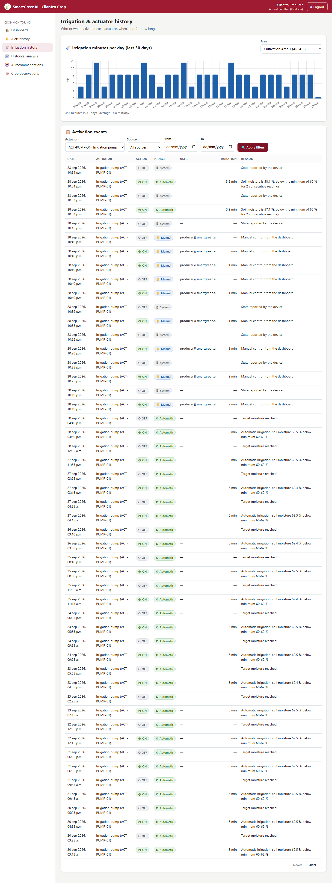
Figure US17-T4-1. The same events on the irrigation history screen. (US17-T4_Test_Event_Recording_3.png)
✓ Condition 4: Evidence: Test table and database query screenshot.
How it was verified: Test table and database query.

4. Event recording tests
ID | Case | Steps | Input | Expected | Actual | Result
EV-01 | Manual activation | US15 tests: producer command ON | ACT-PUMP-01 | source MANUAL, user, duration | MANUAL, producer@smartgreen.ai, 5 min | PASS
EV-02 | Automatic activation | US16 engine ON | ACT-PUMP-01 | source AUTOMATIC, no user, duration, reason | AUTOMATIC, user none, 3.5 min | PASS
EV-03 | Database matches the screen | Compare the query with the history screen | both events | same source and duration | match | PASS
Totals: 3 cases · 3 PASS · 0 FAIL

5. Attached files
- US17-T4_Test_Event_Recording_1.csv
- US17-T4_Test_Event_Recording_2.sql
- US17-T4_Test_Event_Recording_3.png

6. Traceability
Related requirements | FR-19, FR-23
Implementation | —
Verification | integration/commands.test.js; acceptance step 12

7. Sign-off
Role | Name | Date | Signature
Responsible | Carlos Ramirez Mendoza | October 29, 2026
Peer reviewer | Jorge Velez Delgado | October 29, 2026
Product Owner acceptance | Alexis Enrique Valle Parra | October 29, 2026
Approval record: Sprint 3 Review & Delivery (October 30, 2026): "Product Owner accepted the seven user stories: all acceptance criteria met."

